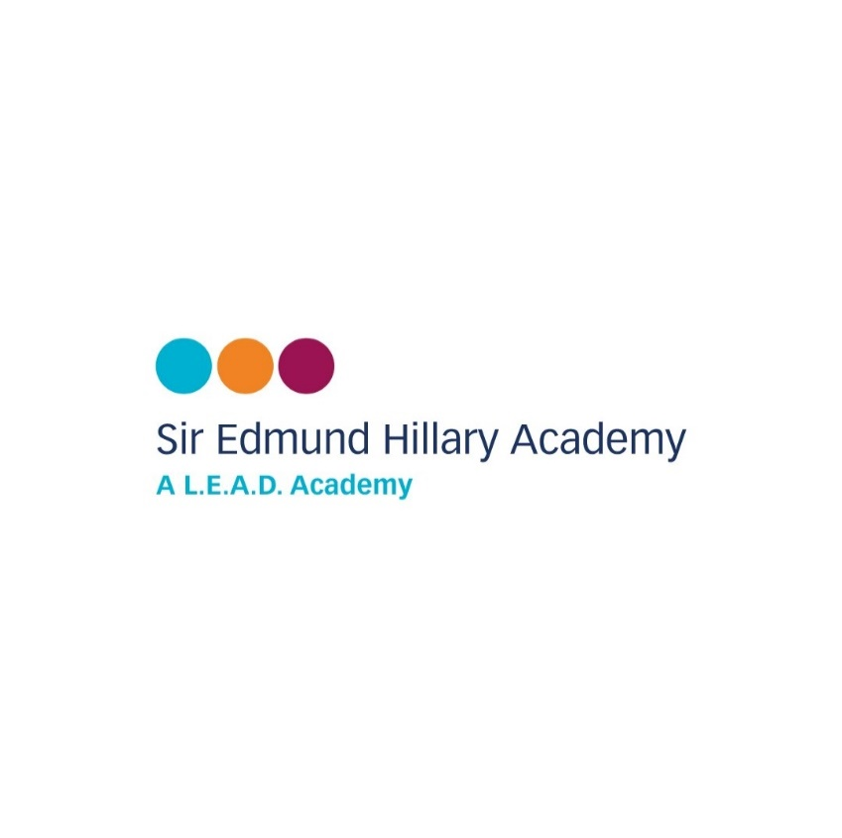

Head of School**:** Mrs. Deborah Eccles

Kingsway Worksop, Nottinghamshire S81 0AN

Telephone: 01909 473 982

office@siredmundhillary.notts.sch.uk

Dear parent / carer,

Our school is taking part in the Partnership for Inclusion of Neurodiversity in Schools (PINS) project. As part of this, all parents and carers are invited to complete a short survey.

Your views are very important – your feedback will help us understand what is working well and where improvements could be made, so that together we can make our school an even better place for all children.

The survey asks about school life, your experiences as a parent/carer, and your child’s experience at school. It has 13 short questions (mostly multiple choice) and takes less than 10 minutes to complete.

The survey is for all parents and carers. If you have more than one child at the school, you are welcome to complete the survey separately for each child.

Your responses are completely anonymous, only the school’s name is identified.

The survey is open from **Monday 8th September** for two weeks.

👉 Please access the survey here:

* **Survey link:** [**https://forms.office.com/e/Mt2QJzBwmr**](https://forms.office.com/e/Mt2QJzBwmr)

Thank you for your support – your feedback will help us keep improving.