
Foundation 1 Newsletter - Autumn 1
Ideas to help support learning about families at home:

- Talk about who is in your family, their names and whether they are a brother, grandad, uncle etc. Talk about family photos together.
- Draw pictures of people together – either with paper and pens, or chalk, with sticks in the mud or paint brushes and water outside! Help your child to learn how to make a round shape for a face, add eyes, nose, mouth, legs and arms.
- Show your child and talk about old photos of when they were babies and when you were a child yourself!

Story Time
Children who have had lots of books read to them at home, who enjoy looking at books with adults and who have talked lots about stories are much more likely to succeed in reading and writing later on. Aim to read a book together at least once per day – adding it to a bedtime routine is perfect.



This code takes you to a video version of Owl Babies you can watch together

The stories we will be focusing on are:
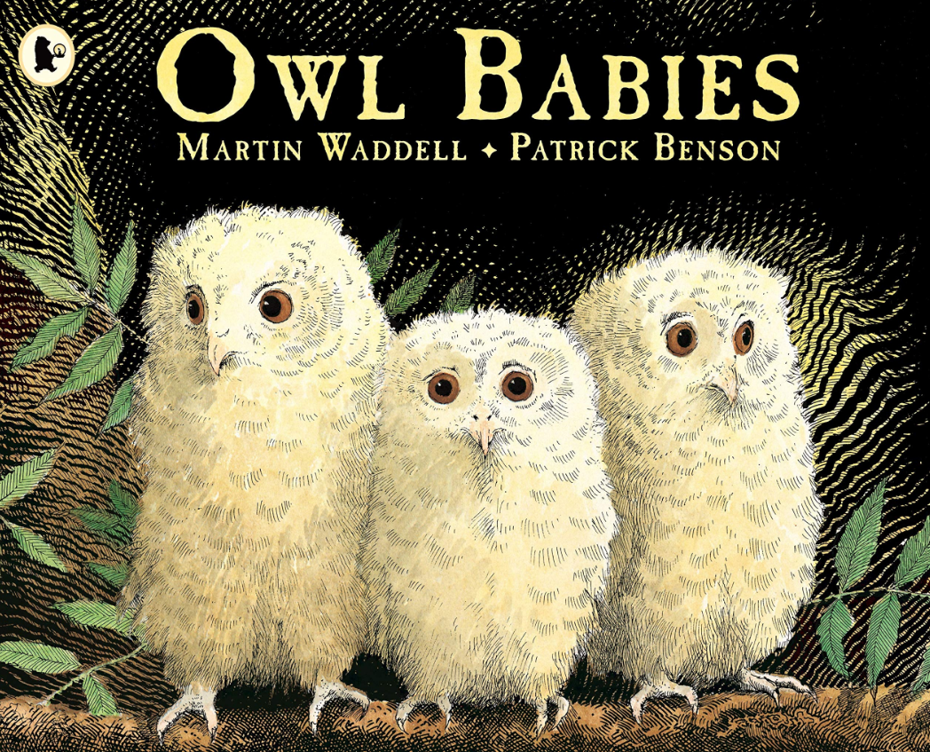
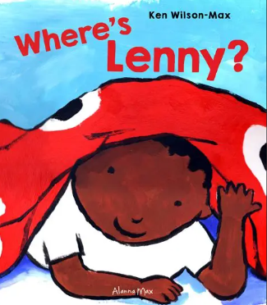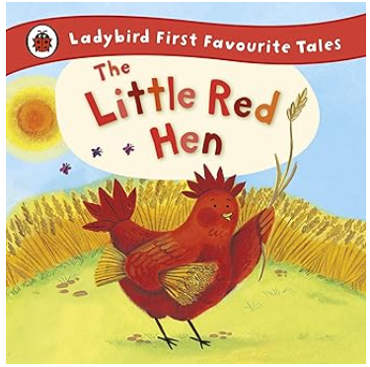

Helping your child with intimate care:
If your child has wet or soiled themselves, we will help your child to get clean and changed. Please let us know if you are not happy with this arrangement and would rather we contact you in the event your child has an accident.
Diary Dates
Last day of the half term: Friday 17th October First Day of Autumn 2: Monday 3rd November

Our main focus over the next few weeks is to settle children into new routines and develop their independence within the setting. Alongside self –chosen activities, children’s learning will be focused around Families and then Autumn. Here are some tips for supporting your child at home, but remember, if you need any advice, ideas or support, just ask!

Nursery Rhymes

Singing nursery rhymes together is very
important. Children love to sing and learn rhymes, especially during times of bonding, such as at bedtime. Rhymes can support early number knowledge, confidence, imagination and speech development.

We have Rhyme Time in school where we teach children new songs and play games related to them. You will get a paper copy of the rhymes every fortnight. Please practise singing these songs at home – we want children to be able to sing most of the words eventually.

The BBC have a great webpage full of new ones to learn.

