I know we live in Worksop.

I know some different buildings and places in Worksop, like The Canch, the library and ADSA.

I know what a map is and enjoy drawing my own maps.

Maths
Understanding the World

I can count to at least 10.
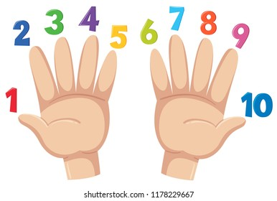

I can make sets of 1,2,3,4 and 5 objects.

I can count a small set of objects and tell you how many there are (up to 10 objects).

I can subitise up to 5 – I don’t need to count, I can see the amount.
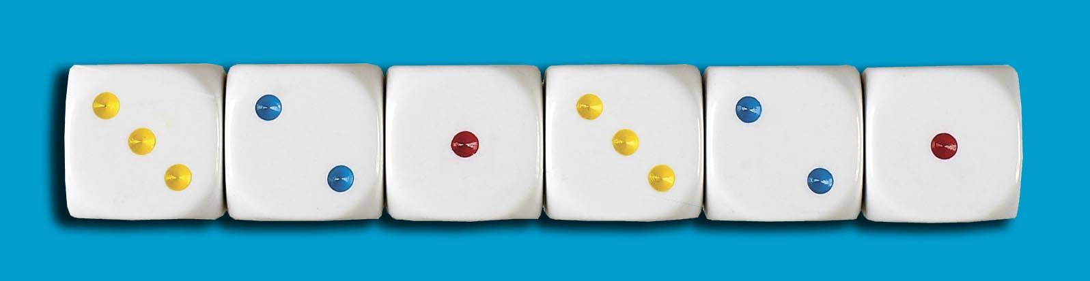

I can make a pattern.
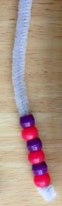

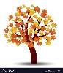

Art & Design
I know what a self-portrait is and can draw a picture of myself.

I can use the right colours.

I can build my house using blocks.
English
A digraph is-
two letters, one sound

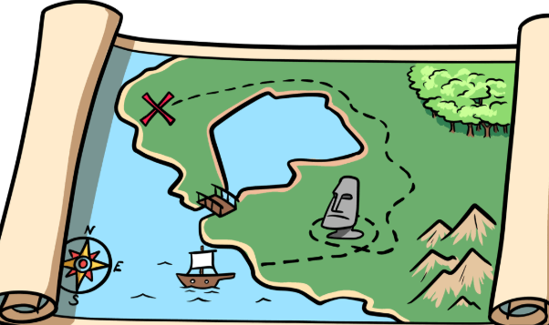

When an adult sound talks a word, I can sound talk and blend: e.g.
Adult says “h – a – t” and I say “h – a – t … hat”

I know the sounds that all these graphemes make:

s a t p i n m d g o c k e u r h ck f b l

I know the names of people in my family and can talk about past experiences with them.

I can talk about my home and how my home might be different to my friends’ homes.

I know how old I am.

I know the year I was born and that it is 2025 now.

I know the 4 seasons and can talk about the weather.

I can draw circles, squares, rectangles and crosses.

I can write some letters, forming them correctly.

I can hold a pencil correctly.

I can write my first name.

I can read these tricky words:

I is the

Phonics

