
Reception Newsletter - Autumn 1

Welcome back after the Summer break, we hope that it has been fun filled! This first half term our main focus we will be on settling children into our routines, forming relationships and developing independence. The children’s learning will be based around the question - ‘Who Am I?’
Into our routines, and learn all about ‘Traditional Tales’.
P.E. will be on a Monday and our focus will be an ‘Introduction to PE’. Please remember that your child needs black shorts and a white t- shirt. Encourage your child to change independently at home.

It’s useful to leave your child’s PE kit in school all week (or all half term) just in case the day has to change last minute.
Please name all items of clothing.

The stories we will be focusing on are:
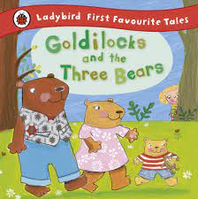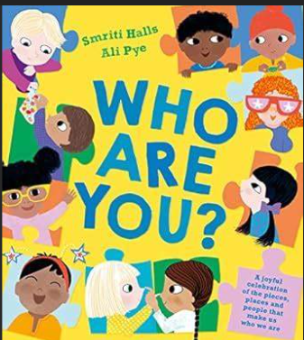
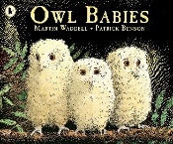

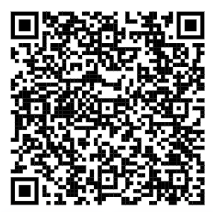
Diary Dates
Last day of Autumn 1: Friday 17th October
Back to school: Tuesday 4th November (Monday 3rd November is an INSET day)

Ways to help your child’s understanding of the world:

- Talk to your child about what makes them unique and special. Who is in their family? What are their favourite things to eat, do, play, see?
- Use comparative language when you are talking about what you see; longer/ shorter, bigger/smaller, heavier/ lighter.
- Observe the changes that are taking place outside as we move towards Autumn.
- Talk about things that have happened in the past in your own child’s life; yesterday, last week, when you were ‘x’ years old.
Home Learning
Each week your child will be given a piece of homework to complete. This will be based upon what we have been learning about together at school. The task is designed to take 10-15 minutes. Please encourage your child to complete it with as much independence as possible. They may have mastered the new skill and be proud of themselves or need a bit more practise at it which is where your help comes in!
We celebrate the homework that children complete and incorporate it into our reward system in school.
Please also encourage your child to read to you at least 4 times per week and make time to share a bedtime story. Please record this reading in your child’s reading log so that they can earn prizes!

Little Wandle Letters and Sounds

This QR code will take you to the Parents’ Page
of the Little Wandle website. There are lots of
good videos to help you to understand how we
teach phonics in school. We want you to feel
confident about helping your child at home, so
please take some time to watch them – any
questions please come and ask!

