
Reception Newsletter - Autumn 2
Diary Dates
Christmas tree festival: Friday 5th December (AM) Reception nativity: Tuesday 9th December (AM)
Reception Christmas party: Thursday18th December (PM) End of Autumn term: Friday the 19th December

Welcome back after the half-term holiday This half-term we continue to focus the children’s learning around the question - ‘Who Am I?’

We also have lots of exciting things to look forward to; such as the Christmas tree festival at Priory Church and our nativity performance!

P.E. will be on a Wednesday and our focus will be ‘Fundamentals of P.E’. Please remember that your child needs black shorts and a white t- shirt. Please encourage your child to change independently at home!

It’s useful to leave your child’s PE kit in school all week (or all half term) just in case the day has to change last minute.
Please name all items of clothing.


The stories we will be focusing on are:
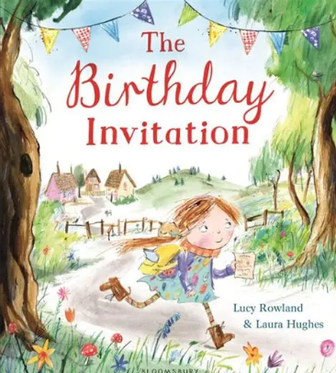

Ways to help your child’s understanding of celebrations:

- Help your child learn their birthday and understand that this is the day they were born.
- Talk about the months of the year and help your child to learn them by saying them in order.
- Look at a calendar together, writing down when special events are happening.
- Encourage your child to help you when writing cards or invitations – talk about who and what it is for. Ask them to write their own name inside cards that they send.

Speaking

Supporting your child’s speaking skills is the most important way you can help your child to learn.

Make time to talk and encourage them to hold conversations, recall things that you have done together and speak in full sentences.

Check out the BBC Tiny Happy People website for advice and activity ideas. Here is the page for 4-5 year olds:



Little Wandle Letters and Sounds

This QR code will take you to the Parents’ Page
of the Little Wandle website. There are lots of
good videos to help you to understand how we
teach phonics in school. We want you to feel
confident about helping your child at home, so
please take some time to watch them – any
questions please come and ask!

